

CE-222E Computer Organisation and Assembly language
Instructor: Prof Dr Ghulam Abbas

4097 x 17 Computer System Report

Abdul Rehman Asif | 2024027
Youraj Ali Karim | 2024666
Muhammad Ghazali Khan | 2024380

Date of Submission: April 20th, 2026

Abstract

This report presents a design of a 4096 x 17 computer system, detailing every major subsystem like ALU and CU. The machine is inspired by the Mano’s version of a basic computer detailed out in his book.
A distinguishing feature of this design is the addition of a dedicated B register, which serves as the secondary operand source for all ALU operations. This register eliminates the need to route operands exclusively through multi operand computations. The comparator unit evaluates multiple comparison conditions such as greater to or equal to. Additionally, The CU is improved with the use of a ring counter which moves through 16-time cycles replacing the 4-bit sequence counter.
The instruction set architecture defines multiple commands with their respective instructions, dividing the instruction set into 1 bit flag, 1 5-bit opcode, 11 bit addressing bits.

Table of Contents

1.Main Memory unit 5
2.Register and flip flops 6
2.1: Registers 6
2.2 Flip flops 7
3.The Bus System 9
3.1 The Data bus 10
3.2 The Control Bus 12
4. ALU- Arithmetic Logic unit 13
4.1 Demorgan Logic Expansion Unit 15
4.1.1 Derivation of each Function 16
1.Derivation of NAND (Not AND) 16
Derivation of NOR (Not OR) 16
Derivation of XOR (Exclusive OR) 16
4.1.2 Functions Produced by the Unit 17
4.1.3 Control Unit Integration and Timing 17
4.1.4 Detailed Operation 17
4.1.5 Placement Within the ALU 17
4.1.6 Practical Application 18
4.2 Shift Unit 18
4.3 Comparator Unit 21
4.4 ALU selection 22
5. Instruction Set Architecture 22
5.1 Addressing modes 22
5.2 Memory Reference Instructions 23
ROT 24
5.3 Register Reference Instructions 25
5.4 I/O Control Instructions 26
6. The Control Unit 26
6.1 Instruction Decoder 27
6.2 Ring Counter 27
7.Encryption Section 28
7.1 ENCRYPTION 28
7.2 DECRYPTION 28
8. Micro operations 29
8.1. Fetch Phase 29
8.2 Decode Phase 30
8.3 Execute Phase - All Instructions 30
9. The Interrupt Cycle 33
10. Complete Computer Flowchart 34
11.Bibliography 34

1.Main Memory unit
The primary memory subsystem of this computer is organised into an array of 4096 addresses words, each words having a 17-bit width. This capacity of words is denoted as 4096 x 17, where the first term indicates the number of uniquely addressable locations and the second term indicates the bit width of each location. Because the memory unit comprises of 4096 locations, twelve address bits are reserved as unique to each word, and the twelve its memory address is sized accordingly.
Every word stored in memory can have multiple purposes depending on the context in which it is accessed. When fetched as part of a program flow, it is treated as an instruction and when accessed as a data operand, its lower bits are interpreted numerically. The seventeen-bit instruction code divides into three fields, arranged from the most significant to least significant.
- Bits 16(one bit)- Addressing Mode: when set to 0, the operand field contains a direct memory address and when set to 1, it contains an indirect pointer to the effective address.
- Bits 15-11(five bits)- Operation code(opcode): uniquely identifies which of the thirty-two base operations is executed.
- Bits 10-0(eleven bits)- specifies either the memory location of the operand in direct mode or holds the memory location that holds the effective address in indirect mode.
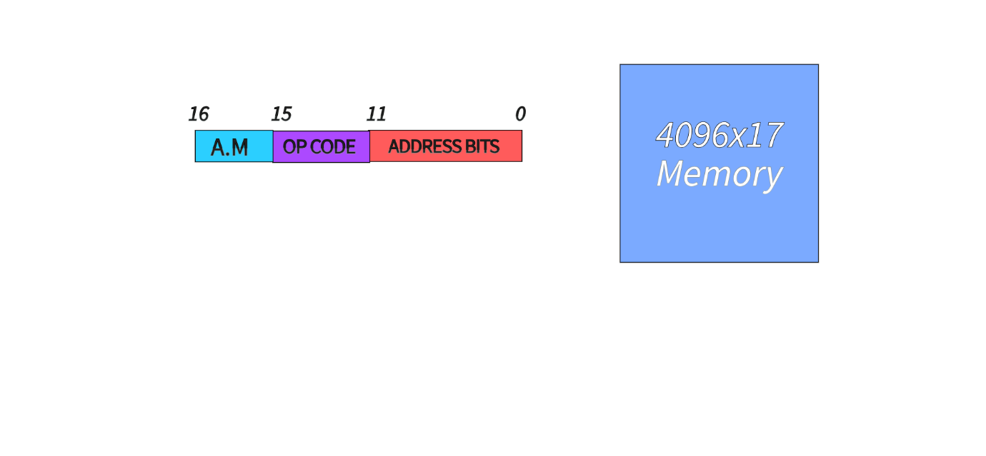
Figure 1

2.Register and flip flops

2.1: Registers
The processor contains set of dedicated registers that act as fast, storage elements used to hold data, addresses, and status information while instructions are being fetched, decoded and executed. Each register is directly connected to an internal bus system and can be loaded, incremented or cleared under the direction of control signals issued by control unit. Table 1 enumerates every register present in this design along with its symbolic name and functional role.

Register Name | Symbol | Function
Instruction Register | IR | Holds the instruction word retrieved from main memory for decoding
Temporary Register | TR | Provides a secondary short-term holding location for intermediate values during multi step operations
Memory Address Register | MAR | Holds the address of the memory location being used to read and write
Accumulator | ACCM | Stores the primary operand and accumulates results produced by the ALU
B register | B | Holds the secondary operand supplied to the ALU, enabling direct register to register operations without requiring memory access
Output Register | OPR | Buffers data to be sent to external output devices
Input Register | IPR | Buffers data received from external input devices before being processed by the CPU
Comparison Register | CPR | Stores the four-bit result produced by the ALU Comparator Unit, encoding whether the primary operand is greater than, less than, equal to, or not equal to the secondary operand
Program counter | PC | Stores the memory address of the next instruction to be fetched and executed
Table 1 — CPU Registers

A notable improvement in this architecture relative to the mano machine is the introduction of the B register. Where a conventional mano machine must reload one operand from memory before every two operand ALU operation, the B register provides a secondary operand to perform multiple arithmetic operations. Subsequent ALU operations can be achieved in a single instruction cycle without issuing a second memory access.

The Comparison register merits a separate discussion. The CPR encodes the result into a four-bit word. The four-bit positions represent four mutually exclusive operations including greater than, less than, equal to and not equal. All four-bit instructions can run individually when flag combinations are decoded.
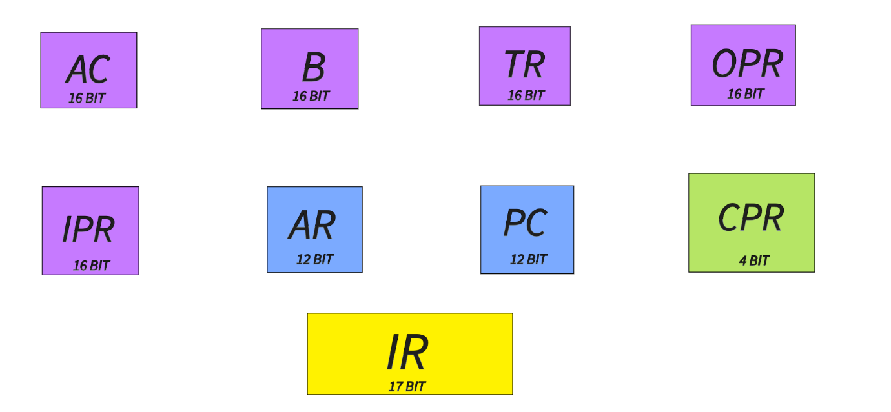
Figure 2

2.2 Flip flops
The processor uses several single-bit storage elements called flip-flops to record status conditions that affect the flow of execution. Each flip-flop is set or cleared by a specific micro-operation and is checked by the control unit during the right timing step. Table 2 lists every flip-flop in the design.
Flip-Flop | Description
IEN | Interrupt Enable flag. Set to 1 by ION and cleared to 0 by IOF. When high, the processor acknowledges interrupt requests from peripheral devices at the end of each instruction cycle.
FGI | Input Flag. Set to 1 by external hardware when new data is present in the Input Register (IPR). Cleared by the processor after the data is read. Prevents the CPU from sampling stale input.
FGO | Output Flag. Set to 1 by external hardware when the Output Register (OPR) is ready to accept new data. Cleared by the processor after it writes to OPR. Prevents data from being overwritten before the peripheral has consumed it.
R | Interrupt Request latch. Set to 1 when an external device asserts an interrupt and IEN is high. Cleared when the processor acknowledges the interrupt and enters the interrupt service cycle.
I | Indirect Addressing mode bit. Loaded from bit 16 of the instruction word during the decode phase. When high, the processor performs an extra memory read to resolve the effective address before executing the instruction.
AOFB | Arithmetic Overflow / Carry-out Bit. Captures the carry-out produced by the full adder array during addition and subtraction. Also serves as the bridge bit in ROT (rotate-through-carry) instructions, connecting the displaced bit of one rotation to the next.
S | Start-Stop flag. When cleared to 0 the processor halts and the clock is effectively gated off. Set to 1 to resume execution. The END instruction clears S and resets the Program Counter.
Table 2 — Processor Flip-Flops

3.The Bus System
The interconnection architecture adopts a dual bus topology, in which a dedicated data bus and a dedicated control bus operate in parallel. Separating both buses allows for non-contention between data bearing signals and control bearing signals which would otherwise arise on a single shared bus whenever a register value must be transferred at the same time when a control signal is launched.
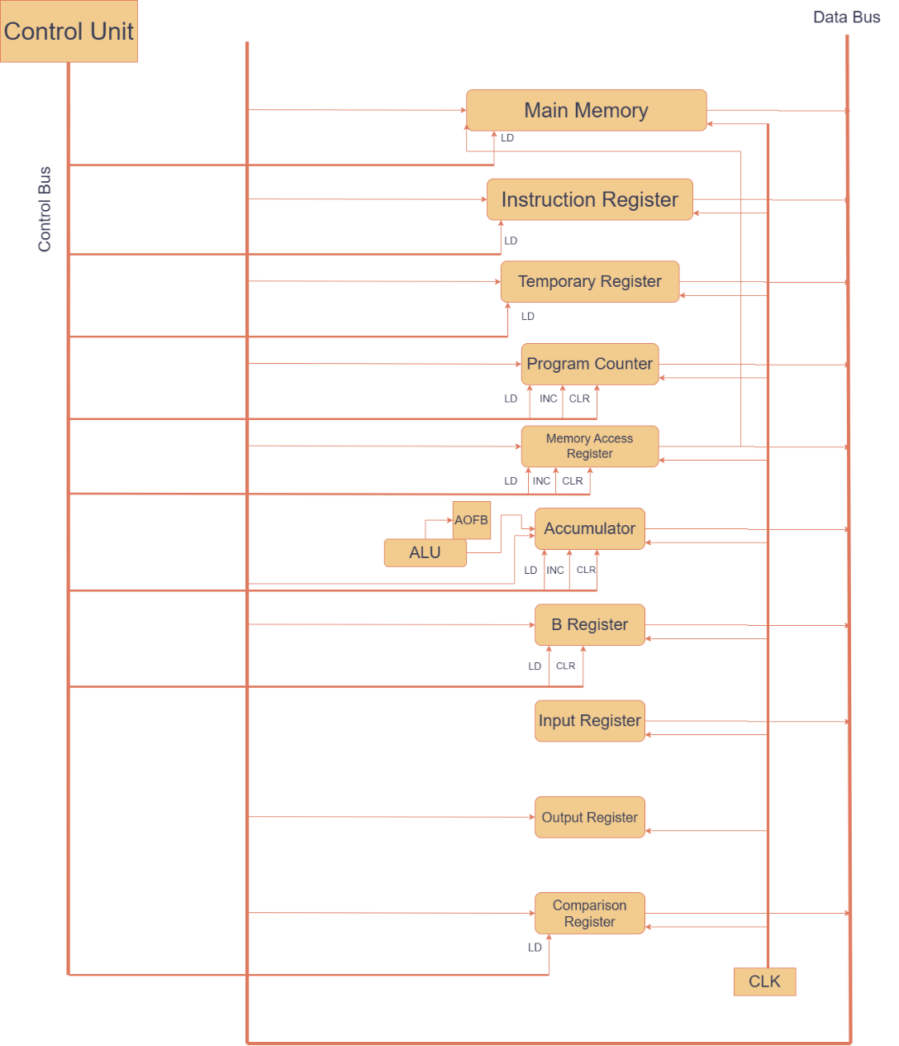
Figure 3

3.1 The data bus
The data bus is sixteen bits wide and provides the pathway along which register contents are transferred from one CPU component to another, and between CPU and main memory. A 4 to 16 decoder is used with which it has 4 select inputs S3-S0 driven by control unit. Only 10 output lines are actively connected, the remaining 6 outputs are unused for future expansion. An additional Enable Decoder input must be kept high before any register output is driven into bus and when ED is low all, tri state buffers are placed in their high impedance state. Table 3 provides all valid combinations.

ED | S3 | S2 | S1 | S0 | Selected Register
0 | X | X | X | X | None (bus disabled)
1 | 0 | 0 | 0 | 0 | Main Memory
1 | 0 | 0 | 0 | 1 | Instruction Register
1 | 0 | 0 | 1 | 0 | Temporary Register
1 | 0 | 0 | 1 | 1 | Comparison Register
1 | 0 | 1 | 0 | 0 | Memory Address Register
1 | 0 | 1 | 0 | 1 | Accumulator
1 | 0 | 1 | 1 | 0 | B Register
1 | 0 | 1 | 1 | 1 | Input Register
1 | 1 | 0 | 0 | 0 | Arithmetic Logic Unit
1 | 1 | 0 | 0 | 1 | Program Counter
Table 3 Data Bus decoder Select Combinations
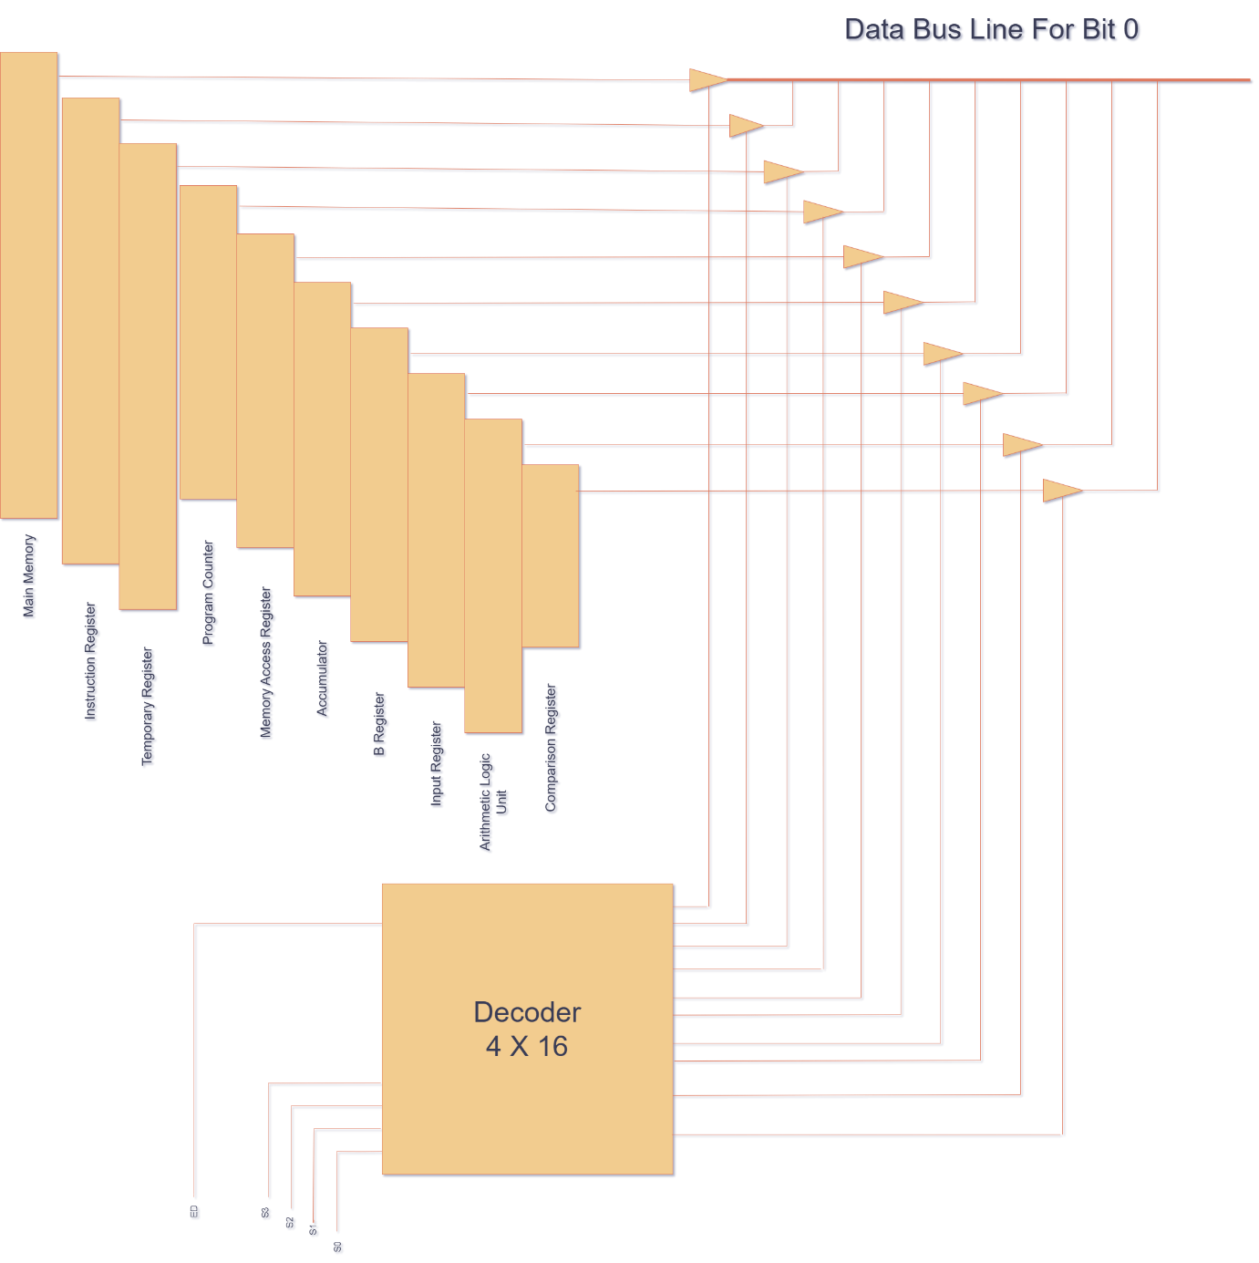
Figure 4

3.2 The Control Bus
The control bus provides timing signals to each register. The control unit performs three operations which include: loading a value from the data bus, incrementing register’s internal counter or clearing its contents to zero.
Every register receives a common clock signal that is distributed via control bus. This clock signal synchronises all register state transitions to same edge. Table 4 includes the complete set of control bus bit definitions.

Control Bit | Target Register | Effect
L_MM | Main Memory | Load: brings data from the data bus into Main Memory
L_IR | Instruction Register | Load: writes the data bus value into the IR
L_TR | Temporary Register | Load: writes the data bus value into TR
L_PC | Program Counter | Load: overwrites the PC with the data bus value
L_MAR | Memory Address Register | Load: Adds the data bus address into the MAR
L_AC | Accumulator | Load: writes the data bus value into ACCM
L_B | B Register | Load: writes the data bus value into B
L_CR | Comparison Register | Load: latches the comparator result into COMP
E_D | Decoder (bus output) | Enable: places the selected register's contents onto the data bus
I_PC | Program Counter | Increment: advances the PC to point to the next instruction
I_MAR | Memory Address Register | Increment: increments the MAR during block memory operations
I_AC | Accumulator | Increment: increments the ACCM value directly
C_PC | Program Counter | Clear: resets the PC to address zero
C_MAR | Memory Address Register | Clear: resets the MAR
C_AC | Accumulator | Clear: zeroes the accumulator
Table 4 Control Bus Bit Definitions

4. ALU- Arithmetic Logic unit
The ALU receives two operand inputs: the primary operand from the accumulator and the secondary operand from the b register and produces a single result that is routed to the comparison register depending on the operation performed. The ALU is structures as four parallel subunits: An arithmetic unit, a logic unit, a shift unit and a comparator unit. A multiplexer can be used to select between these units and their subsequent operations.
The mano machine has used a ripple carry adder internally for its full adder. Our choice is to make use of a carry lookahead adder.
To perform binary addition using microoperations in hardware we need registers that hold the data and digital components that perform the addition. A digital circuit that produces a sum of binary digits of any length is called a binary adder. In this architecture we are going to use a full adder using carry look-ahead logic. In Mano’s architecture the ripple carry logic is used which means that for example bit 3 cannot be computed until it receives the carry from bit 2 which waits for the carry from bit 1. This is called propagation delay that happens due to the inner gates in the full adder blocks. Now to tackle this problem we use carry look-ahead logic (CLA) which basically computes all the carry bits at once. The working of the CLA is described below:
Phase 1: Input Conditioning and the Mode Bit (M):
The Full Adders will receive two 16-bit inputs and a control bit. For now, let’s call the two inputs A and B and the control input M. The control input M is used to select if the operation happening is addition or subtraction. If the operation being performed is addition than B remains the same but if it is subtraction, then we need to take the 2’s complement of B to subtract it from A. Each input of B and M is fed into a XOR gate. Let’s call the output of the XOR gate C.
C = B XOR M
ADDITION:
For Addition the input M is 0. In the XOR gate acts as a buffer so that the input B remains unchanged. This makes the input B and output C identical.
SUBTRACTION:
For Subtraction the input M is 1. In this the XOR gate acts as an inverter It performs complement on the input B. This makes the output C the opposite of input B.
Initial Carry (Co):
The control input M is also wired directly into the initial carry-in of the entire circuit. So, when M=0, Co also becomes zero. And when M=1, Co also becomes 1 which adds the necessary 1 to complete the 2’s complement transformation of B.
S1 | S0 | Operation
0 | 0 | Addition — computes ACCM + B and stores the result in ACCM
0 | 1 | Subtraction with Borrow — computes ACCM − B − Borrow
1 | 0 | Addition with Carry — computes ACCM + B + Carry
1 | 1 | Subtraction — computes ACCM − B
Table 5 Arithmetic Unit Operation Select

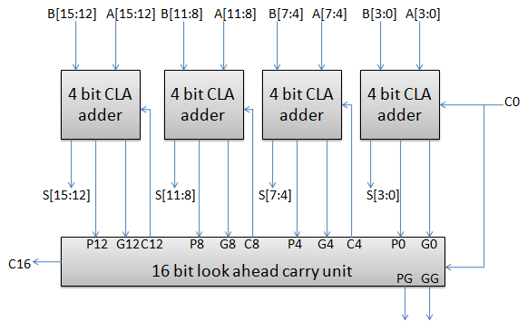
Figure 5

4.1 Demorgan Logic Expansion Unit
The processing element employs various one-bit registers known as flip-flops for keeping track of conditions that affect the execution sequence. The state of each flip-flop depends on some micro-operation, and the flip-flop is read by the control element at an appropriate time. Table 2 shows all the flip-flops used.

Feature | Standard Logic Unit | DeMorgan Logic Expansion Unit
Role | Direct operator | Expansion / synthesis unit
Method | Fixed gates (AND, OR, NOT) | Derives functions using DeMorgan’s theorems
Outputs | AND, OR, NOT(A) | NAND, NOR, XOR, XNOR, masking operations
Complexity | Simple | Moderate (derived from existing signals)

The unit uses DeMorgan’s identities:
¬(A · B) = ¬A + ¬B
¬(A + B) = ¬A · ¬B

These equations allow transformation between AND ↔ NOR structures and OR ↔ NAND structures. For each bit position i (0 to 15), the unit first generates helper signals:

Helper Signal | Generation Method
Ai | Direct from ACCM[i]
Bi | Direct from B[i]
Ai' | Inverter on Ai
Bi' | Inverter on Bi
Ai · Bi | AND gate
Ai + Bi | OR gate

4.1.1 Derivation of each Function

1.Derivation of NAND (Not AND)
Target: NAND = ¬ (A · B)

Step | Operation | Source
1 | Compute A · B | From standard AND gate
2 | Invert the result | Pass through NOT gate

Derivation of NOR (Not OR)
Target: NOR = ¬ (A + B)

Step | Operation | Source
1 | Compute A + B | From standard OR gate
2 | Invert the result | Pass through NOT gate

Derivation of XOR (Exclusive OR)
Target: XOR = A ⊕ B = (A + B) · (¬A + ¬B)

Step | Hardware Action
1 | Generate A + B | (OR gate)
2 | Generate ¬A and ¬B | (inverters)
3 | Generate ¬A + ¬B | (second OR gate)
4 | AND the results together | (AND gate)

4.1.2 Functions Produced by the Unit
Select (S2 S1 S0) | Output | Description | Boolean Expression
000 | NAND | NOT (A AND B) | ¬ (A · B)
001 | NOR | NOT (A OR B) | ¬ (A + B)
010 | XOR | Bits differ | A ⊕ B
011 | XNOR | Bits same | ¬ (A ⊕ B)
100 | A AND B' | Masking (clear where B=1) | A · ¬B
101 | A' AND B | Reverse masking | ¬A · B
110 | A OR B' | Selective set | A + ¬B

4.1.3 Control Unit Integration and Timing
Timing Step | Micro-Operation
T4 | DM2–DM0 ← IR[2:0], DME ← 1
T5 | ACCM ← DMU_Result, DME ← 0, RIC ← 0

4.1.4 Detailed Operation
This section explains how the DMU produces seven operations from AND, OR and NOT. These three are the base computations.

4.1.5 Placement Within the ALU
- The DMU gets a sixteen-bit operand from the accumulator and a sixteen-bit secondary operand from the B register.
- When the control unit sends a signal called Demorgan Enable (DME) and a three-bit function select signal (DM2–DM0) the DMUs output multiplexer drives the ALU result bus.
- All seven operation paths are straightforward. Do not need any extra time. So, the result is available in one clock cycle.
- The DMU is like a two-layer multiplexer bank.
- The first layer. OR and NOT for all sixteen bits at the same time.
- The second layer combines these results to produce NAND, XOR and XNOR.
- A 7-to-1 output multiplexer, controlled by DM2–DM0 selects one of the seven results for each bit.

4.1.6 Practical Application
The DMU is useful because it makes difficult logic operations simple for the programmer. Without the DMU, getting XOR would need many instructions such as loading values, using AND or NOT and then combining results with OR. XNOR is also easier because it is not available directly in the original Mano machine. In the Caesar Cipher Encryption Unit of Section 8, XOR can be used for bit masking and data changes in a fast way. The XNOR result can quickly check if two-bit patterns are the same, which is faster than sending both values to the comparator unit.

4.2 Shift Unit
The shift unit displaces the bit pattern in the accumulator either one position to the left or one position to the right. Multiple shift variants are provided. In logical shift operations, vacated positions are always filled with zero. In circular shift operations, the bit displaced from one end of the register reappears at the opposite end, preserving information. In arithmetic shift operations, right shift replicates the sign bit into empty most significant position to preserve signed magnitude of negative numbers, while left shifts fill empty least significant position with zero. Any extra bit is stored in a flip flop.
The E bit acts as a safety net for bits falling off the edge of your register, while the OF (Overflow) flag serves as an alarm bell for corrupted arithmetic signs. To understand the exact math you provided, think of the logic gates as simple traffic controllers. In your first equation, OF=(A1⊕A0​)⋅S⋅(M1​​M0​), the (XOR) gate constantly compares your sign bit (A_0) with the adjacent bit (A_1) to see if a shift would flip the number's sign, but the subsequent (AND) gates act as a strict bouncer, ensuring the overflow alarm is only allowed to ring if the control signals (S,M1,M0) confirm the system is explicitly performing an Arithmetic Left Shift. Meanwhile, your second equation, E=~(S). A3​+S.A0, essentially turns the E bit into a directional catcher's mitt using S as a toggle switch. If S dictates a right shift ( ~S), the logic routes the bit falling off the far-right side (A_3) into E; but if S dictates a left shift, the logic swings over to catch the original sign bit (A_0) falling off the left. Just as you pointed out, these two mechanisms work together perfectly.If an arithmetic left shift triggers an overflow, your original sign bit isn't lost to the void; it is safely preserved inside the E bit for the system to retrieve or evaluate later.

S2 | S1 | S0 | Operation
0 | 0 | 0 | SHFL: Logical Shift Left: vacated LSB is filled with 0
0 | 0 | 1 | SHFR: Logical Shift Right: vacated MSB is filled with 0
0 | 1 | 0 | CIRL: Circular Shift Left: MSB wraps around to LSB
0 | 1 | 1 | CIRR: Circular Shift Right: LSB wraps around to MSB
1 | 0 | 0 | ATSHL: Arithmetic Shift Left: LSB is filled with 0
1 | 0 | 1 | ATSHR: Arithmetic Shift Right: sign bit is replicated into MSB
Table 7 Shift Unit Operation Select
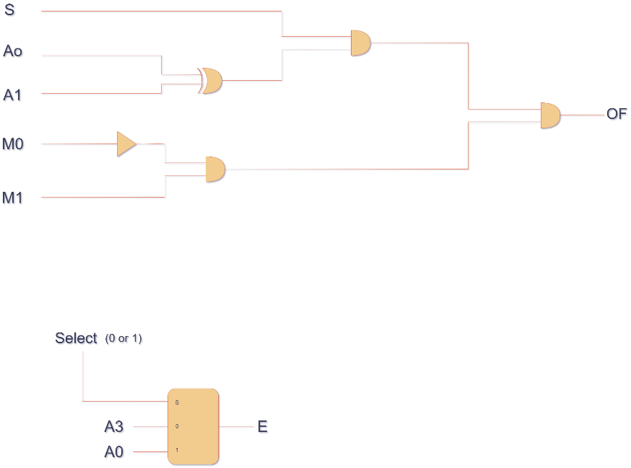
Figure 6
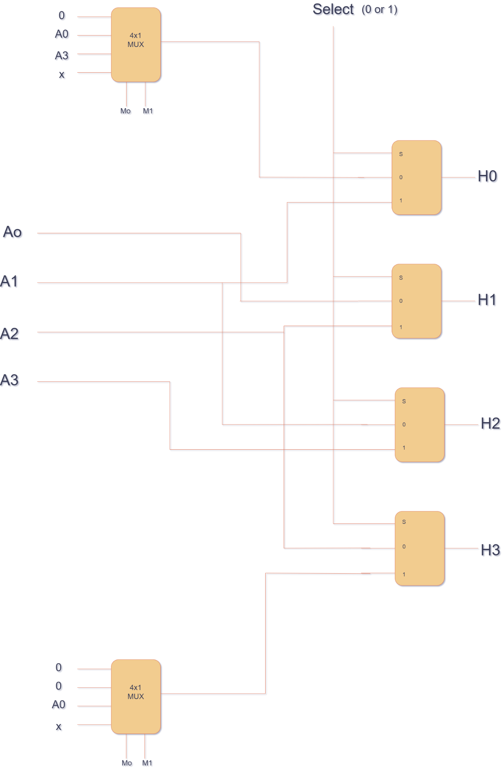
Figure 7

4.3 Comparator Unit
The comparator evaluates relationship between the value currently held in the accumulator and the value held in the B register, producing a four-bit result that encodes four possible combinations.
Condition | CPR Value | Description
ACCM < B | CPR = 0100 | Primary operand is less than secondary operand
ACCM > B | CPR = 1000 | Primary operand is greater than secondary operand
ACCM = B | CPR = 0010 | Both operands are equal
ACCM ≠ B | CPR = 0001 | Operands are not equal
Table 8 Comparator Unit Output Encoding
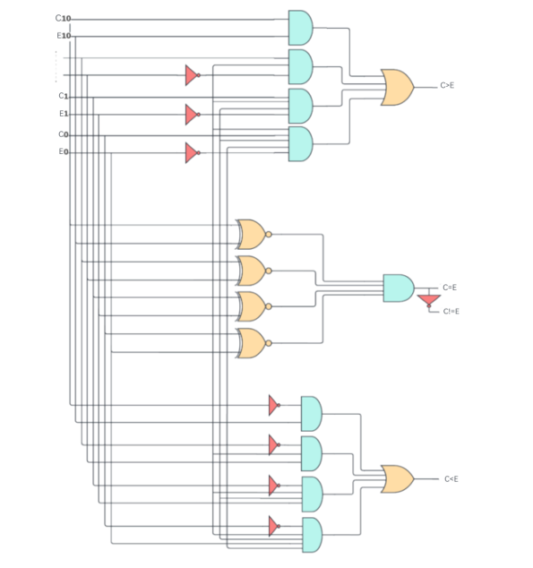
Figure 8

4.4 ALU selection
The four subunits that are connected in parallel, are selected based on two signal inputs listed in the table below.

S4 | S3 | Selected ALU Component
0 | 0 | Arithmetic Unit
0 | 1 | Demorgan Unit
1 | 0 | Shift Unit
1 | 1 | Comparator Unit
Table 9 ALU Component Selection

5. Instruction Set Architecture
The instruction set architecture defines operations that the processor can perform as seen from the perspective of an assembly language performer. It encompasses the encoding of instructions in memory, the addressing modes available to reference operands, and the language of each instruction in terms of the names of registers, memory and flag status.

5.1 Addressing modes
Two addressing modes are supported, selected by bit 16 of the instruction word. In direct addressing mode (bit 16=0), the 16-bit operand field contains memory address at which operand itself resides. The processor reads the address once to obtain operand. In indirect addressing mode (bit 16 =1), the 16-bit operand field contains the address of a memory word that itself holds the effective address of the operand.

5.2 Memory Reference Instructions
When bits 15-11 of the instruction word encode a value in the range 00000 through 11111 and the addressing mode bit is interpreted as a direct / indirect selector, the result is one of the operations formed below.

Op-code | Mnemonic | Function
00000 | LDA | Load the value at the specified memory address into the Accumulator
00001 | STA | Store the Accumulator's current value into the specified memory address
00010 | ADD | Add the value at the specified address to the Accumulator Register, storing overflow in AOFB
00011 | SUB | Subtract the value at the specified address from the Accumulator Register.
00100 | AND | Bitwise AND of the Accumulator with the value at the specified memory address
00101 | OR | Bitwise OR of the Accumulator with the value at the specified memory address
00110 | JMP | Unconditional jump: load the specified address into the Program Counter
00111 | SWP | Exchange the Accumulator contents with the value at the specified address via the B Register
01000 | BSA | Branch and Save: store the PC at the target address and transfer control to target+1
01001 | CMP | Compare the Accumulator against the value of the ; encode the relational result into CPR
01010 | ROT | Rotate the Accumulator left or right through carry as specified by the operand field
01100 | BPA | Branch if Positive Accumulator: jump to the target address if ACCM > 0
01101 | SEA | Set Accumulator: load the immediate constant encoded in the lower operand bits directly into ACCM
01110 | STZ | Store ACCM to the address, then increment the address pointer in MAR (store-and-advance)
01111 | ENCR | Encrypt one character using the Caesar Cipher key held in INPR[5:7]
10000 | DECR | Decrypt one character via Caesar Cipher
10001 | LDB | Load the value at the specified memory address into the B register
10010 | STB | Store the B register current value into the specified memory address
10011 | INP | If FGI = 1, load input register into Accumulator and clear FGI to 0.
10100 | OUT | If FGO = 0, store Accumulator into Output Register and clear FGO to 0.
10101 | DMG | Execute Demorgan unit operation on accumulator and b register, store result in accumulator.
Table 10 Memory-Reference Instructions

BPA
Branch if Positive Accumulator BPA performs a conditional jump to the specified memory address only if the current value of the Accumulator is greater than zero (ACCM > 0). If the condition is not met, the PC remains unchanged, and the execution continues to the next instruction.

ROT
ROT rotates the Accumulator through the carry flag by one bit position in the direction and mode specified by the operand field. Unlike the circular shift operations in the Shift Unit, ROT passes the displaced bit through flip flop, enabling multi-word rotation chains where the carry propagates between successive ROT instructions on adjacent words. Table 12 documents all four rotation variants.

Operand (Hex) | Operation | Micro-operation Detail
001 | Rotate Left through Carry | ACCM ← (ACCM << 1) | AOFB; AOFB ← MSB of original ACCM
002 | Rotate Right through Carry | ACCM ← (AOFB << 11) | (ACCM >> 1); AOFB ← LSB of original ACCM
004 | Rotate Left (no carry) | ACCM ← (ACCM << 1) | MSB; effectively a circular left rotate
008 | Rotate Right (no carry) | ACCM ← (LSB << 11) | (ACCM >> 1); effectively a circular right rotate
Table 11 ROT Instruction Operand Encodings

5.3 Register Reference Instructions
Register-reference instructions operate exclusively on internal registers and flags; they do not reference main memory. They are identified by opcodes whose addressing-mode bit is repurposed as part of the opcode. Table 13 lists all register-reference instructions.

Mnemonic | Function
NOT | Complement every bit of the Accumulator (bitwise NOT): ACCM ← ACCM'
CLA | Clear the Accumulator to zero: ACCM ← 0
END | Halt program execution
ADDB | Add B register to Accumulator
SUBB | subtract B from Accumulator
ANDB | bitwise AND of AC and B
ORB | bitwise OR of AC and B
NEG | Negate the Accumulator: compute the two's complement (ACCM ← 0 − ACCM)
MOVB | Copy Accumulator into B register
CLRB | Clear the B Register to zero: B ← 0
Table 12 Register-Reference Instructions
NEG
Negate Instruction NEG computes the arithmetic two's complement negation of the Accumulator. It does this by using ACCM ← 0 − ACCM. This process involves inverting all bits and adding one. Any overflow that occurs is stored in the AOFB flip-flop. NEG makes signed subtraction simpler when the programmer needs to negate a value before using the ADD instruction. This way, it avoids an extra subtraction step.

5.4 I/O Control Instructions
Two dedicated I/O instructions govern the processor's interrupt capability. ION (Interrupt ON) sets the IEN flip-flop to 1, enabling the interrupt system so that peripheral requests will be acknowledged at the conclusion of the current instruction cycle. IOF (Interrupt OFF) clears IEN to 0, masking all interrupt requests. These instructions provide the programmer with precise control over critical sections of code that must not be interrupted.
Mnemonic | Function
ION | Enable interrupts: IEN ← 1
IOF | Disable interrupts: IEN ← 0

6. The Control Unit
The control unit acts like a brain to the computer, responsible for turning abstract data into concrete sequence of instructions that can be carried off. It observes the state of the decoded instruction and the current timing position, then asserts the precise combination of control signals that directs every other component to perform correct action at correct moment.

6.1 Instruction Decoder
Each time a new instruction word is loaded into the Instruction Register at the end of the fetch phase, the decoder breaks it apart into its three fields right away. The five opcode bits feed into a 5-to-32 binary decoder which raises exactly one of the thirty-two output lines D0 through D32, the one that matches the current opcode, while every other output stays low.

6.2 Ring Counter
Our ring counter is built to handle 16 timing signals. A single bit moves from t0 to t15, then goes back to T0. Only one timing signal is active at any moment. the RIC (Reset Instruction Counter) signal is activated; the active bit jumps straight back to T0.
We chose 16 stages because several of our instructions, particularly CMP and ROT, require quite a few timing steps to complete.

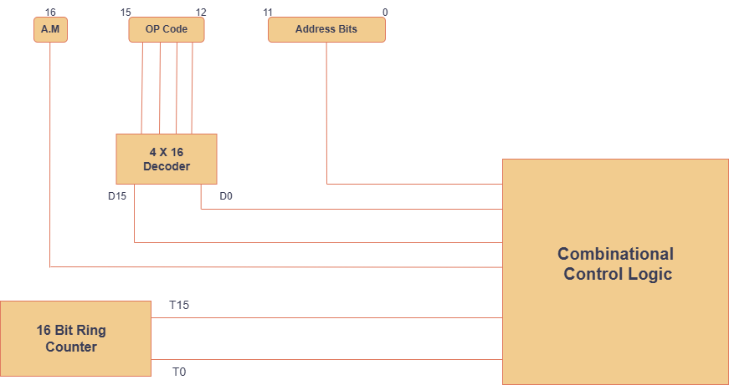
Figure 9

7.Encryption Section
We will implement the Caesar Cipher in the encryption unit. The user will be provided with a documentation sheet in which the alphabets are mapped from 0 (A) to 25 (B). The user should provide a single alphabet i.e INPR(0-4) and the key i.e INPR(5-7).

7.1 ENCRYPTION
If the user uses the operation ENCR ‘to be enc’, send INPR(0-4) to AC and ADD with INPR(5-7). The number 26 will be stored in a particular memory location. Send 26 into B register. The comparator unit will compare the value in AC with the 26 in B register and if smaller, this input will be sent to OUTR. If equal or greater, the input will be sent back to the AC and will be subtracted from 26. Then the input will be sent to the OUTR.

ENCR T4: AC <- INPR(0-4), AC <- AC + INPR (5-7)
T5: B <- M[AR] (LOCATION OF 26),
IF (CPR = 0100), OUTR <- AC
F (CPR = 1000 OR CPR = 0010), AC <- AC + B’ +1, OUTR <- AC
T6: AC <- 0, INPR <- 0, B <- 0, SC <- 0

7.2 DECRYPTION
The decryption process is entirely the same except that instead of adding the key with the alphabet, we subtract them. To make decryption easier, we use
(Cipher + (26 – Key)) mod 26
The user uses DECR ‘to be decrypted’.
Hence first store the INPR (5-7) bits first in the AC and negate (2’s complement).
Bring 26 from the memory address into B register. Subtract B from AC and store in AC. Add INPR (0-4) and the remaining process is the same.

ENCR T4: AC <- INPR(5-7), AC <- AC’, AC <- AC + 1,
B <- M[AR] (LOCATION OF 26),
AC <- AC + B,
AC <- AC + INPR (0-4)

T5: IF (CPR = 0100), OUTR <- AC
IF (CPR = 1000 OR CPR = 0010), B <- B’, B <- B+1,
AC <- AC + B,
OUTR<- A
T6: AC <- 0, INPR <- 0, B <- 0, SC <- 0

8. Micro operations
A microoperation is a sequence operation performed by the basic machine. It can do multiple tasks which include transferring value between registers. Every instruction is broken down to steps; smaller steps that help achieve the true task.
Every single instruction moves through three phases: Fetch, Decode and execute. Only after the above phases, the execution branches into instruction’s own specific microoperation sequence.

8.1. Fetch Phase
In the Fetch cycle, the basic machine fetches instructions from main memory and then is sent off for decoding. This takes one to two clock cycles.

T0: MAR ← PC

The current value of the program counter is added into MAR, which can then be read.

T1: IR ← M[MAR], PC ← PC + 1

Main memory returns the 17-bit word at the MAR and put add it into IR. At the same time PC is incremented so it points towards the next instruction. It simplifies JMP instructions.

8.2 Decode Phase
During the decode phase, the instruction set decodes and if the indirect address is active, only then will it be executed. Otherwise, this step is skipped.

T2: D0…D15 ← decoder (IR [11:15]), MAR ← IR [0:10], I ← IR [16]

The Instruction Decoder splits the IR contents: the five op-code bits (positions 11–15) are decoded into outputs D0 to D31, the eleven-bit operand address (positions 0–10) is added into the MAR, and the addressing-mode bit (position 16) is stored in the I flip-flop ().

T3 (indirect mode only, activated when I = 1):
T3: MAR ← M[MAR]

If indirect addressing is one, the word at the current MAR is fetched and used to overwrite the MAR with the effective address. After T3, the MAR contains the address of the operand and then execute phase proceeds from t4.

8.3 Execute Phase - All Instructions
From t4 onwards the specific microoperations are executed.

Instruction | Execute-Phase Micro-operations
AND | T4: B ← M[MAR]  T5: ACCM ← ACCM ∧ B, RIC ← 0
LDA | T4: ACCM ← M[MAR], RIC ← 0
ADD | T4: B ← M[MAR]  T5: ACCM ← ACCM + B, AOFB ← Cout, RIC ← 0
STA | T4: M[MAR] ← ACCM, RIC ← 0
BSA | T4: M[MAR] ← PC  T5: MAR ← MAR + 1  T6: PC ← MAR, RIC ← 0
JMP | T4: PC ← M[MAR], RIC ← 0
STZ | T4: M[MAR] ← ACCM  T5: MAR ← MAR + 1, RIC ← 0
SWP | T4: B ← M[MAR]  T5: M[MAR] ← ACCM  T6: ACCM ← B, RIC ← 0
CMP | T4: B ← M[MAR]  T5: If (ACCM > B) then COMP ← 8 (binary 1000)  T6: If (ACCM < B) then COMP ← 4 (binary 0100)  T7: If (ACCM = B) then COMP ← 2 (binary 0010)  T8: If (ACCM ≠ B) then COMP ← 1 (binary 0001), RIC ← 0
NEG | T4: B ← M[MAR] (load operand for reference if needed)  T5: ACCM ← 0 − ACCM, AOFB ← Cout, RIC ← 0
ROT | T4: (operand in MAR selects rotation type)  T5: If (M[MAR]=001) then ACCM ← (ACCM<<1) |AOFB, AOFB←MSB_old  T6: If (M[MAR]=002) then ACCM ← (AOFB<<11) |(ACCM>>1), AOFB←LSB_old  T7: If (M[MAR]=004) then ACCM ← (ACCM<<1) |MSB_old (circular left)  T8: If (M[MAR]=008) then ACCM ← (LSB_old<<11) |(ACCM>>1), RIC ← 0
BPA | T4: If (ACCM > 0) then PC ← M[MAR], RIC ← 0  Else: RIC ← 0 (fall through to next instruction)
SEA | T4: ACCM ← IR [0:11] (load lower 12 bits of instruction word directly), RIC ← 0
NOT | T4: ACCM ← ACCM’, RIC ← 0
CLA | T4: ACCM ← 0, RIC ← 0
DMG | T4: DM2–DM0 ← IR[2:0], DME ← 1  T5: ACCM ← DMU_Result, DME ← 0, RIC ← 0
ENCR | T4: ACCM ← INPR[0:4], ACCM ← ACCM + INPR[5:7]  T5: B ← M[MAR](=26); if CPR=0100: OUTR←ACCM; if CPR=1000 or 0010: ACCM←ACCM+B’+1, OUTR←ACCM  T6: ACCM←0, INPR←0, B←0, RIC←0
DECR | T4: ACCM ← INPR [5:7], ACCM ← ACCM’, ACCM ← ACCM+1, B ← M[MAR](=26), ACCM ← ACCM+B, ACCM ← ACCM+INPR [0:4]  T5: if CPR=0100: OUTR←ACCM; if CPR=1000 or 0010: B←B’+1, ACCM←ACCM+B, OUTR←ACCM  T6: ACCM←0, INPR←0, B←0, RIC←0
LOADB | T4: B ← M[MAR], RIC ← 0  (Load memory word directly into B register)
STOREB | T4: M[MAR] ← B, RIC ← 0  (Store B register into memory word)
ADDB | T4: ACCM ← ACCM + B, AOFB ← Cout, RIC ← 0  (Register-to-register add; no memory access)
SUBB | T4: ACCM ← ACCM − B, AOFB ← Cout, RIC ← 0  (Register-to-register subtract; no memory access)
ANDB | T4: ACCM ← ACCM ∧ B, RIC ← 0  (Bitwise AND of AC and B; no memory access)
ORB | T4: ACCM ← ACCM ∨ B, RIC ← 0  (Bitwise OR of AC and B; no memory access)
MOVB | T4: B ← ACCM, RIC ← 0  (Copy Accumulator value into B register)
INP | T4: If (FGI=1), ACCM <- IPR, FGI<-0, RIC<-0 else: RIC<-0
OUT | T4: If (FGO=1), OPR <- ACCM, FGO<-0,RIC<-0 else: RIC<-0
END | T4: S ← 0, PC ← 0, RIC ← 0
ION | T4: IEN ← 1, RIC ← 0
IOF | T4: IEN ← 0, RIC ← 0
Table 13 Complete Execute-Phase Micro-operations

9. The Interrupt Cycle
Interrupt cycle is a sequence of operations that the basic machine carries out when an external device requires output. When IEN is set two one and the r flip flop is also set to 1, only then interrupt cycle activated. When both are activated, the machine immediately fetches the next instruction but does not perform multiple operations at the same time.
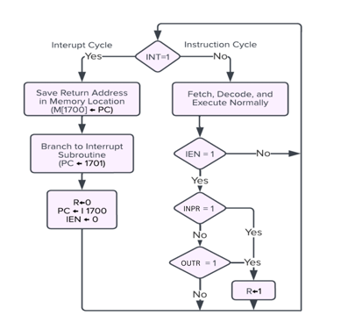
Figure 10

10. Complete Computer Flowchart
The flowchart below illustrates the complete instruction execution cycle of the processor, from initialisation through fetch, decode, and execute, looping back continuously until the END instruction halts the machine.

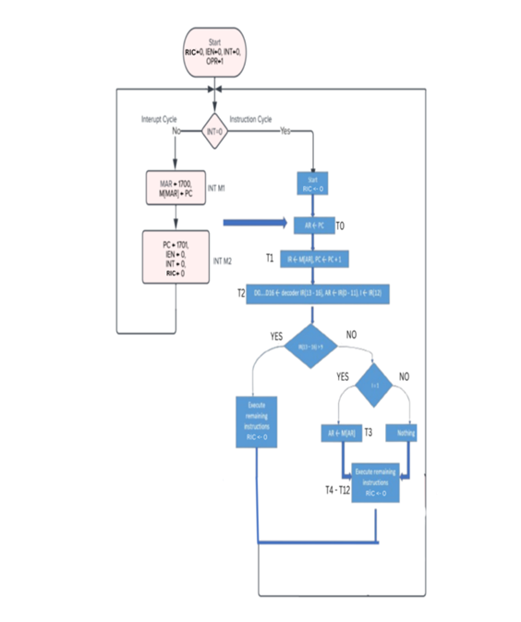
Figure 11

11.Bibliography
- ALU- Arithmetic Logic Unit, https://www.researchgate.net/figure/bit-carry-look-ahead-adder_fig2_340928087
- Logic Unit, Computer System Architecture Third Edition By Morris Mano.
- Shift Unit, Computer System Architecture Third Edition By Morris Mano.
- The Interrupt Cycle, Computer System Architecture Third Edition By Morris Mano.

